Frontiers in Insect Science

Special Issue: Forest Insect Invasions – Risk Mapping Approaches and Applications

Claire E. Rutledge

Department of Entomology

The Connecticut Agricultural Experiment Station

123 Huntington St.

New Haven, CT 06511

[Claire.Rutledge@ct.gov](mailto:Claire.Rutledge@ct.gov)

203 974-8484

**Temporal and spatial dynamics of the emerald ash borer invasion in Connecticut as shown by the native digging wasp *Cerceris fumipennis* (Hymenoptera: Crabronidae).**

Claire E. Rutledge – Connecticut Agricultural Experiment Station, New Haven CT

Robert E. Clark – Washington State University, Pullman WA

**Abstract**

Detecting and monitoring populations of the invasive emerald ash borer is crucial to successful management of the pest. However, the beetle’s cryptic habit makes both tasks difficult. Biosurveillance, uses the native, solitary, ground-nesting hunting wasp, *Cerceris fumipennis* (Hymenoptera: Crabronidae) to detect emerald ash borer. The wasp hunts adult buprestid beetles and brings them to the nest to provision brood cells. By intercepting the hunting wasps, we can learn which species of buprestids are in the surrounding forest, and their relative proportions. In this paper we share results of 10 years of survey of the emerald ash borer in Connecticut Using this metric, we watched the progress of EAB populations at multiple sites; from first detection, through the population peak and through to the population crash. We also observed the spatial distribution of the beetle as it moved through the state. The average time from first detection to population crash was 9 years. On average, populations peaked 3 years after first detection, and remained at peak levels for 3-4 years. Population decline was gradual and took another 3-4 years. Spatially, we saw that EAB entered the state in northern New Haven County and spread in a radial fashion across the state. No evidence of a second introduction was seen. Using this dense picture of EAB activity in the state, we can make predictions of when and where management efforts should be focused.

Keywords: biosurveillance, invasive species, *Agrilus planipennis*, monitoring

**Introduction**

Emerald ash borer (*Agrilus planipennis* Fairmaire) is native to Far Eastern Asia and was first detected in North America in 2002. Emerald ash borer, EAB, is a phloem feeder that feeds on members of the genus *Fraxinus* (Oleacea). In its native range, the beetle is considered a secondary pest. It is unable to establish and develop in ash trees that are healthy and only thrive in trees whose defenses have been compromised by other causes, such as decadence, disease, or drought (Wang, et al., 2010). Its ecological role is like many North American species of *Agrilus*, such as *Agrilus anxius* Gory and *Agrilus bilineatus* (Weber) feeding on their dying hosts in the birch and oak families (Haack & Benjamin, 1982; Muilenburg & Herms, 2012). However, healthy trees of North American species of *Fraxinus* are successfully attacked by EAB (Rebek, et al., 2008). Emerald ash borer has little competition for healthy ash phloem in North America, and no specialized natural enemies. These two factors have allowed EAB to multiply exponentially and spread across North America (Herms & McCullough, 2014).

The population dynamics of EAB in a new location, and its impact on ash trees, have been modeled by a simple exponential curve for the growth phase of the invasion, followed by a sharp drop in EAB population after the peak of the outbreak (Figure 1). The increasing portion of the exponential curve model has been validated for tree health in 3 urban areas by Sadof, et al. (2017), and many studies that use tree health as a proxy for EAB levels show similar curves (Klooster, et al., 2014; Miller & Mueller, 2020). Longer-term empirical data on the EAB population levels that move beyond the exhaustion of the main ash source have been collected largely in the context of monitoring the impact of biological control agents (Duan, et al., 2017; Duan, et al., 2019). Understanding what is happening with the EAB population itself is important for long-term planning of ash management and recovery and to monitor the potential upswing in EAB numbers with the growth of new trees.

Another pattern that has been intensively observed has been the movement of EAB through the landscape. A pattern of anthropogenic satellite populations (Mercader, et al., 2009) gradually coalescing with the larger invasive population has been seen throughout the beetles’ 20+ year history in North America. Natural spread of the infested area by flight has been shown to be 1 to 2 km a year but rate of spread increases as the population of EAB increases (Sargent, et al., 2010). The larger pattern of spread has been shown through detection surveys such as the USDA APHIS purple prism trap survey (USDA APHIS, 2022).

In this paper we take advantage of data from 10 years of monitoring prey catch of *Cerceris fumipennis* (Hymenoptera: Crabronidae) to examine both the temporal and spatial spread of EAB in the state of Connecticut. We have amassed a collection of over 30,000 individual buprestids. This large database allows us to examine the temporal and spatial spread of EAB in Connecticut with great robustness and may allow us to fill in some of the gaps in observed EAB population dynamics.

*Cerceris fumipennis* is a solitary ground-nesting wasp that uses adult buprestid beetles to provision their nests. The wasp is native to eastern North America and is broadly found from Maine to Florida and west to Texas (Krombein, et al., 1979). Male wasps emerge first, and mate with female wasps as they emerge from their underground nest cells. Females dig burrows and once they have dug the initial brood cell begin to hunt. Females live an average of 18 days (Nalepa, 2012) but can survive up to 6 weeks. They sequentially dig cells for their young, filling each with sufficient beetle mass to support a larva through its development. The female wasp will dig, provision, and lay a single egg in as many cells as they can. The number of their offspring is limited by the rate at which they can dig and provision the cells before they die. The larvae then complete their development feeding on the paralyzed beetles and spin a cocoon (Hook & Evans, 1991). In the northern part of their range, including Connecticut, they overwinter as pre-pupae in their cocoons. In the southern part of the range the first generation completes their development and emerges to begin the second generation. The diapause does not seem to be obligate, as partial second generations have been observed in Connecticut (Rutledge, et al., 2015 ). Each female wasp digs and provisions her own nest, but nests are usually found in aggregations of tens to hundreds of individual withing the same area (Nalepa, et al., 2012).

Like many solitary wasps, *Cerceris fumipennis* is a generalist hunter within a specific taxon, in its case adult beetles in the family Buprestidae. *Cerceris fumipennis* has a known prey range of > 100 sp. of buprestids (Swink, et al., 2013; Brownie, et al., 2015; Bohne, et al., 2019; Hallinen, et al., 2020). Based on their known prey, their prey seems to be limited to buprestids (with < 0.1% Cerambycidae and Chrysomelidae (Rutledge, et al., 2011)) that have an arboreal habitat as adults, are adults during the wasps’ hunting season, and are within the size range (4 – 20 mm) used by *Cerceris fumipennis* (Volkova, et al., 1999; Hellman, et al., 2014).

Foraging wasps should maximize the mass of beetles collected for amount of effort (Pyke, 2019). Wasps should take the most readily available prey rather than searching for specific prey species. Therefore, changes in the abundance of available prey will be reflected in the abundance of species in the captured prey. Work by Swink et al. (2013) show this pattern for *C. fumipennis* in North Carolina during an outbreak of the hemlock borer, *Phaenops fulvuguttata* (Coleoptera: Buprestidae), caused by hemlock decline due to *Adelges tsugae* (Homoptera: Adelgidae). The stress caused to hemlocks by the hemlock wooly adelgid was reflected in a rise of hemlock borers as a proportion of prey captured by the wasp. This has been shown for other solitary hunting wasps as well *viz*, *Hypodynerus andeus* (Packard) (Vargas, et al., 2014) and *Sphex ichneumoneus* (L.) (Brockmann, 1985). Both species specialize in a family of prey, but prey choice is constrained by habitat, size and phenology, and like *C. fumipennis*, prey composition fluctuates with prey abundance.

In this paper, we use the relative proportion of EAB in the prey of *C. fumipennis* colonies to examine the temporal history of the EAB infestation at single locations, as well as the spatial pattern of EAB distribution over time in Connecticut.

**Materials and Methods**

Collection Sites - Aggregations of *Cerceris fumipennis* were identified by surveys of baseball fields throughout Connecticut, as baseball fields are the most common habitat for the wasp (Nalepa, et al., 2012). New aggregations were added each year, and others were dropped as the numbers of wasps in colonies fluctuated.

The beetles were collected from late June – August of 2009-2022. The goal was 50 beetles/ site/ year, (Careless, et al., 2014), but some sites were only visited once, and others were visited multiple times for multiple years. Only data from 2012, the year of initial EAB discovery in the state, onward is presented. Sampling intensity reflected wasp colony size fluctuations, focus on EAB surveillance, and personnel. Beetles were collected by netting and releasing wasps carrying prey or by collecting beetles abandoned on the field by the wasps. (Carrier & Jackson, 2012; Rutledge, et al., 2013).

Proportion of EAB as related to time of EAB detection - a subset of sites that had greater than 30 beetles collected in the year before initial detection and 50 beetles collected at the site for one or more years after the initial detection of Emerald Ash Borer at that site were selected. For each site and year, the proportion of EAB/ total beetles was calculated and classified by year relative to EAB detection, 0 = the year of detection, 1 = the year after detection, etc. regardless of what calendar year that detection occurred. We visually compared the dynamics of the average proportions of EAB at a site after infestation to the theoretical wave model (Figure 1).

Modeling proportion of EAB against time of EAB detection – proportion of EAB as a function of time of EAB detection was modeled using a generalized linear mixed effects model with a logit link. The full fixed effects model included time and time2, and the full random effects model included random slopes over time and time2 and random intercepts for collection site. Random effect selection was performed by comparing the full model to three simpler models (random intercepts and random slopes over time, random slopes over time only, and random intercepts only) based on (lowest) AIC. Modeling and model selection were conducted in R version 4.1.2 (R Core Team, 2021) using the lme4 and lmerTest packages. 95% confidence intervals were obtained using the ggeffects package version 1.1.4, and results were plotted using ggplot2 version 3.4.1.

Spatial analysis of EAB spread – For each year, starting in 2012 when EAB was first detected in Connecticut, we calculated the proportion of EAB in *C. fumipennis* prey by colony. Data from sites where less than 20 beetles were collected that year were excluded. For each year we calculated Moran’s Index to confirm that the data showed significant spatial autocorrelation (ESRI, 2022). We then used the Empirical Bayesian Kriging tool in ArcPro (ESRI, 2022) to interpolate proportions between collection sites and construct a series of maps, one per year, that show the density of EAB by color gradient. Visual analysis of the resultant patterns was then conducted. Speed of spread, based on first observation of EAB at each site, was estimated with a Bayesian Gaussian process gradient model using the invasionSpeed package (Goldstein et al., 2019) in R.

**Results**

The first detection of emerald ash borer in Connecticut was made using *C. fumipennis* in 2012 in the town of Prospect, CT (Rutledge, et al., 2013). Since then, EAB has been officially detected, through either by *C. fumipennis*, APHIS-directed purple-prism trapping, in-person visits by CAES personnel or by photographs showing clear signs of EAB, in all 8 counties of Connecticut, and in 166 of its 169 towns. For 3 of those counties the first detection was made by *C. fumipennis*, as were 99 of the town detections (Supplemental Data Figure 1).

Proportion of EAB as related to time of initial EAB detection – We had 48 sites for which we had a known first EAB detection year. This was defined as a site at which more than 30 beetles (X = 70.9 ± 5.25, Median = 66) were collected directly prior to the year EAB was first collected. For each site, data were only included in the analysis for years in which at least 50 beetles were collected. This number had been determined to be the point at which most available species at a site had been collected (Careless, et al., 2014). Sites where EAB was detected in later years, have data available for fewer years post-detection. We have 3 sites which date from our first detections of EAB in 2012, and these sites were 10 years post-detection as of 2021. Altogether 15,601 beetles are in the data set were used to create this curve (Figure 2, Supplementary Table 1).

Average proportion of EAB in *C. fumipennis* prey roughly followed the theoretical model proposed for population growth; the proportion of EAB rose steeply, crested, then dropped with the peak occurring at 4.05 years. The model which best fit the data was a quadratic equation.

On average, the proportion of EAB collected in year zero was 0.108 (SE ± 0.026). If we assume the population starts at 1% and doubles each year, as in the theoretical model, that puts detection by *C. fumipennis*, on average, 4 to 5 years into the invasion. There was a range of EAB proportions from 0.01 – 0.52 in the first detection year.

The mean proportion of EAB in *C. fumipennis* prey increased for 3 years after the initial detection. The proportion of EAB plateaued for the next 3 years, and then, starting 7 years after the initial detection, the proportion of EAB in wasp prey declined reaching an average of 0.108 (SE ± 0.07) by year 9.

Spatial analysis of EAB spread – The number of sites on which the mapping was based in each year averaged 56 (SE ± 4.01, range 35 – 77). In 2020 – 2021 there were fewer sites surveyed due to difficulty recruiting volunteers during COVID quarantines, and unfavorable weather conditions. This was especially true in the Northeastern corner of the state. The resultant density predictions should be taken with caution for that part of the state in those years. Moran’s Index, a measure of autocorrelation in spatial data, was significant in each year (Table 1), indicating that the data were good candidates for Empirical Bayesian Kriging. The models of EAB proportion across the landscape of Connecticut generated by Empirical Bayesian Kriging are shown in Figure 3. Statistics for Empirical Bayesian Kriging are available in the supplemental data Table 1. Estimated speed of spread was 20.53 km/year (SE ± 2.09).

**Discussion**

Detection of cryptic invasive species is critical for management. However, monitoring, especially monitoring that extends beyond initial detection, is seldom sustained long-term due to the difficulty of sampling. In this study we used *Cerceris fumipennis* prey capture as a proxy measurement for EAB presence and prevalence. This has allowed us to document both the temporal and spatial changes of EAB populations over the 10 years since EAB was detected in Connecticut.

Temporally, the rise of EAB as a proportion of prey captured by *C. fumipennis*, roughly mirrors the theoretical model. On average, the proportion of EAB in *C. fumipennis* prey was 8.7% in the first year of detection. This is consistent with detection at year 5 of the infestation and is the threshold at which infestations are commonly detected by trapping (Rutledge, et al., 2013; Sadof, et al., 2017). The proportion of EAB in *C. fumipennis* prey increased year over year, plateaued for 3 years, and then decreased. One striking difference from the theoretical curve is the prolonged crest and gradual drop in EAB density in the post-crest portion of the curve. The theoretical curve drops steeply one year after the peak as it posits that all available ash has been exhausted. However, the sudden population drop seen in many eruptive forest pests, such as *Lymantria dispar* *dispar* (L.), is driven not only by decreases in food quality and availability, but by increasing predation by generalist predators, and by epizootics (Elkinton, 1990; Hoch, et al., 2001). While food availability, and generalist predation, primarily by woodpeckers and generalist parasitoids of woodborers, are likely drivers of EAB population decline (Jennings, et al., 2013, 2015), there is as-of-yet no evidence of epizootics impacting EAB in North America (Castrillo, et al., 2009). The lack of specialized pathogens may explain the more gradual population descent seen in the *C. fumipennis*-based data.

Alternatively, the prolonged crest and gradual population decline seen in our data could be due to an averaging effect across many sites. There was variation between sites and years in these patterns and several factors that could be contributing to that variation. Ash is not distributed equally across the landscape. Although we did not test this explicitly it seems likely the density of ash in the 1.5 km foraging range of each *C. fumipennis* site (Rutledge 2023, in press) will impact both the peak proportion of EAB at the site, and the length of that peak. Another source of variation between sites is the timing of data collection each year. In Connecticut, *C. fumipennis* hunting season typically starts in mid-late June, with a peak during the first 2 weeks of July and lasting into August. Emerald ash borer, by contrast, typically emerges in early June and adult numbers tend to drop off by mid-July. Thus, sites for which a year’s data was collected in late July is likely to have a lower proportion of EAB in their catch than sites for which a year’s data was collected in early July. Finally, there were sites at which EAB was detected early or late in the infestation. For example, we had a site for which EAB had been detected in neighboring sites ringing it, but no EAB showed up in prey at this site for 2 years. On the other hand, we had sItes for which EAB was detected one year, and it then took another 3 years for another EAB was caught. However, despite these factors, the aggregated data clearly reflect population patterns of EAB.

We were also able to obtain data on not only the spatial distribution of detection of EAB as it moved through the state, but its density at each site in each year it was sampled. We could then use empirical Bayesian kriging to generate maps to provide a clear picture of the invasion ‘wave’ (*sensu* (Mercader, et al., 2009) as it moved across the state. The data clearly show the beetle spreading out in a radial fashion from its presumptive invasion site in northern New Haven County. The density dynamics are as expected, in each new area the density is at first low, and then quickly increases before gradually decreasing. Another pattern that is shown is that there was likely only one successful establishment of EAB in the state. At no point do we see loci of high EAB density that are not consistent with spread from the original detection are of northern New Haven County. This spatially explicit information can be used to assist managers to tailor EAB responses.

Future work will look toward understanding the movement we have seen in the light of more explicit landscape analysis. Were there corridors that facilitated movement, barriers to movement, did areas with higher landscape levels of ash slow or increase movement across the landscape? In addition, we plan to continue the survey. Of particular interest is the long-term density of EAB in post-crest areas. Will EAB numbers begin to increase again as the ash resource recovers? *Cerceris fumipennis* will continue to bring us answers.

**Acknowledgements**

This data set is the result of the hard work and support of many people and agencies. First and foremost, I’d like to thank the Wasp Watchers of Connecticut who have collected half of the beetles included in this analysis. Seasonal workers, J. Fitzgerald, J. Tate, E. Kim, D. Hill, S., A. Kahn, all added to the data base and helped to curate the collection. M. Scott deserves special recognition as the primary collector, identifier and curator of the buprestid collection. Many thanks to G. Molaei and J. White for helpful comments on this manuscript. Finally, S. Stebbins has lent much GIS support to the project. Financial support was provided by USFS, USDA Plant Protection Act 7771, and CAPS funding.

# **References**

Bohne, M.J., Rutledge, C.E., Hanson, T., Carrier, N.C., Teerling, C., Weimer, J., Hoebeke, E.R., Lilja, R.L., Digirolomo, M.F. & Dodds, K.J. 2019. Utilizing prey captures by *Cerceris fumipennis* Say (Hymenoptera: Crabronidae) for a survey of Buprestidae (Coleoptera) in New England, USA. *The Coleopterists Bulletin,* 73(2), pp. 369-379.

Bright, D., 1987. The metallic wood-boring beetles of Canada and Alaska. Coleoptera: Buprestidae (No. Part 15).

Brockmann, H., 1985. Provisioning behavior of the great golden digger wasp, *Sphex ichneumoneus* (L.)(Sphecidae). *Journal of the Kansas Entomological Society,* 58(4), pp. 631-655.

Brownie, C., Virgets, W., Allison, J.D., Johnson, C.W., & MacRae T.C. 2015. Observations of *Cerceris fumipennis* (Hymenoptera: Crabronidae) phenology and variation in its buprestid prey in Louisiana. *Florida Entomologist,* 98(4), pp. 1106-1113.

Burr, S. & McCullough, D. 2014. Condition of green ash (*Fraxinus pennsylvanica*) overstory and regeneration at three stages of the emerald ash borer invasion wave.. *The Canadian Journal of Entomology,* Volume 44, p. 768–776..

Careless, P., Marshall, S. & Gill, B. 2014. The use of *Cerceris fumipennis* (Hymenoptera: Crabronidae) for surveying and monitoring emerald ash borer (Coleoptera: Buprestidae) infestations in eastern North America. *The Canadian Entomologist,* 146(1), pp. 90-105.

Carrier, N. & Jackson, L. 2012. *Cerceris* wasp survey protocol.USDA-APHIS-PPQ.

Castrillo, L.A., Bauer, L.S., Liu, H., Griggs, M.H. & Vandenberg, J.D. 2009. Natural infections of *Beauveria bassiana* in *Agrilus planipennis* populations in Michigan*.* Annapolis, MD, USDA Research Forum on Invasive Species .

Coelho, J., Hastings, J. & Holliday, C., 2012. Near-optimal foraging in the Pacific cicada killer *Sphecius convallis* Patton (Hymenoptera: Crabronidae). *Insects,* 3(1), pp. 133-140.

Duan, J., Bauer, L. & Van Driesche, R., 2017. Emerald ash borer biocontrol in ash saplings: the potential for early stage recovery of North American ash trees. *Forest Ecology and Management,* Volume 394, pp. 64-72.

Duan, J.J., Van Driesche, R.G., Crandall, R.S., Schmude, J.M., Rutledge, C.E., Slager, B.H., Gould, J.R., & Elkinton, J.S. 2019. Establishment and early impact of *Spathius galinae* (Hymenoptera: Braconidae) on emerald ash borer (Coleoptera: Buprestidae) in the Northeastern United States. *Journal of Economic Entomology,* 112(5), pp. 2121-2130.

Elkinton, J. 1990. Population dynamics of gypsy moth in North America. *Annual Review of Entomology,* Volume 35, pp. 517-596.

ESRI, 2022. ArcGIS Pro Version 3.1.Redlands, CA

Gayubo, S. 2011. Are solitary progressive-provisioning wasps optimal foragers? A study with the digger wasp *Bembix merceti* (Hymenoptera: Crabronidae). *Behaviour,* 148(2), pp. 191-214.

Goldstein, J., Park, J., Haran, M., Liebhold, A., Bjornstad, O.N. 2019. Quantifying Spatio-Temporal Variation of Invasion Spread. *Proceedings of the Royal Society B,* 286(1894): 20182294.

Haack, R. & Benjamin, D. 1982. The biology and ecology of the twolined chestnut borer, *Agrilus bilineatus* (Coleoptera: Buprestidae), on oaks, *Quercus* spp., in Wisconsin. *The Canadian Entomologist.,* 114(5), pp. 385-396.

Hallinen, M., Wittman, J., & Aukema B.H. 2020. Factors associated with diversity and distribution of buprestid prey captured by foraging *Cerceris fumipennis* (Hymenoptera: Crabronidae). *Environmental Entomology,* 49(6), pp. 1363-1373.

Hellman, W., Fierke, M. & Erbilgin, N. 2014. Evaluating buprestid preference and sampling efficiency of the digger wasp, *Cerceris fumipennis*, using morphometric predictors. *Journal of Insect Science,* 14(1).

Herms, D. & McCullough, D. 2014. Emerald ash borer invasion of North America: history, biology, ecology, impacts, and management. *Annual Review of Entomology,* 59(1), pp. 13-30.

Hoch, G., Zubric, M., Novotny, J. & Schopf, A. 2001. The natural enemy complex of the gypsy moth, *Lymantria dispar* (Lepidoptera, Lymantriidae) in different phases of its population dynamics in eastern Austria and Slovakia, a comparative study. *Journal of Applied Entomology,* Volume 125, pp. 217-227.

Hook, A. & Evans, H., 1991. Prey and parasites of *Cerceris fumipennis* (Hymenoptera: Sphecidae) from central Texas, with description of the larva of *Dasymutilla scaevola* (Hymenoptera: Mutillidae). *Journal of the Kansas Entomological Society,* 64(3), pp. 257-264.

Jennings, D., Duan, J. & Shrewsbury, P. 2015. Biotic mortality factors affecting emerald ash borer (*Agrilus planipennis*) are highly dependent on life stage and host tree crown condition. *Bulletin of Entomological Research,* 105(5), pp. 598-606.

Jennings, D., Duan, J. & Shrewsbury, P. 2015. Biotic mortality factors affecting emerald ash borer (*Agrilus planipennis*) are highly dependent on life stage and host tree crown condition. *Bulletin of Entomological Research,* 105(5), pp. 598-606.

Jennings, D. Gould, J.R., JD, Vandenberg, J.D., Duan, J.J.; & Shrewsbury, PM. 2013. Quantifying the impact of woodpecker predation on population dynamics of the emerald ash borer (*Agrilus planipennis*). *pLoS One,* Volume 8, p. 12.

Klooster, W.S., Herms, D.A., Knight, K.S., Herms, C.P., McCullough, D.G., Smith, A., Gandhi, K.J. & Cardina, J. 2014. Ash (*Fraxinus* spp.) mortality, regeneration, and seed bank dynamics in mixed hardwood forests following invasion by emerald ash borer (*Agrilus planipennis*). *Biological Invasions,* Volume 16, pp. 859-873.

Krombein, K. H. P., Smith, D. & Burks, B., 1979. *Catalog of Hymenoptera in America North of Mexico.* Washington, DC: Smithsonian Institution Press.

McCullough, D.G., Poland, T.M., Tluczek, A.R., Anulewicz, A., Wieferich, J. & Siegert, N.W. 2019. Emerald ash borer (Coleoptera: Buprestidae) densities over a 6-yr period on untreated trees and trees treated with systemic insecticides at 1-, 2-, and 3-yr intervals in a central Michigan forest. *Journal of economic entomology,* 112(1), pp. 201-212.

Mercader, R., Siegert, N., Liebhold, A. & McCullough, D. 2009. Dispersal of the emerald ash borer, *Agrilus planipennis*, in newly‐colonized sites. *Agricultural and Forest Entomology,* 11(4), pp. 421-424.

Miller, F. & Mueller, D. 2020. Protection of ash trees under extended emerald ash borer pressure. *The Great Lakes Entomologist,* 53(1), p. 4.

Muilenburg, V. & Herms, D., 2012. A review of bronze birch borer (Coleoptera: Buprestidae) life history, ecology, and management. *Environmental Entomology,* 41(6), pp. 1372-1385.

Nalepa, C. 2012. Wing wear is a poor estimate of age in *Cerceris fumipennis* (Hymenoptera, Crabronidae}. *Journal of Hymenoptera Research,* Volume 24, p. 43.

Nalepa, C. et al., 2012. Ball diamonds as habitat for nests of *Cerceris fumipennis* (Hymenoptera: Crabronidae): comparisons among three states. *Journal of the Kansas Entomological Society,* 85(3), pp. 219-225.

Pyke, G., 2019. Optimal foraging theory: An introduction. In: *Encyclopedia of animal behavior.* Elsevier Academic Press., pp. 111-117.

R Core Team. 2021 *R: A Language and Environment for Statistical Computing.* Vienna, Austria: R Foundation for Statistical Computing.

Rebek, E., Herms, D. & Smitley, D. 2008. Interspecific variation in resistance to emerald ash borer (Coleoptera: Buprestidae) among North American and Asian ash (*Fraxinus* spp.). *Environmental Entomology,* 37(1), pp. 242-246.

Rutledge, C., Fierke, M., Careless, P. & Teerling, C. 2015 . Degree-day model for emergence of *Cerceris fumipennis* (Hymenoptera: Crabronidae) in northeastern America based on field observations. *Annals of the Entomological Society of America.,* 108(6), pp. 971-977.

Rutledge, C., Fierke, M., Careless, P. & Worthley, T. 2013. First detection of *Agrilus planipennis* in Connecticut made by monitoring *Cerceris fumipennis* (Crabronidae) colonies. *Journal of Hymenoptera Research,* Volume 32.

Rutledge, C., Hellman, W. & Teerling, C.F. 2011. Two novel prey families for the buprestid-hunting wasp *Cerceris fumipennis* Say (Hymenoptera: Crabronidae). *The Coleopterists Bulletin,* 65(2), pp. 194-196.

Sadof, C., 2016. *Emerald Ash Borer Cost Calculator 3.0.* [Online] Available at: <https://int.entm.purdue.edu/ext/treecomputer> [Accessed 17 February 2023].

Sadof, C.S., Hughes, G.P., Witte, A.R., Peterson, D.J., & Ginzel, M.D. 2017. Tools for staging and managing emerald ash borer in the urban forest. *Arboric. Urban For.,* Volume 43, pp. 15-26.

Sargent, C., Raupp, M., Bean, D. & Sawyer, A. 2010. Dispersal of emerald ash borer within an intensively managed quarantine zone. *Arboriculture and Urban Forestry,* 36(4), pp. 160-163.

Swink, W., Paiero, S. & Nalepa, C., 2013. Buprestidae collected as prey by the solitary, ground-nesting philanthine wasp *Cerceris fumipennis* (Hymenoptera: Crabronidae) in North Carolina. *Annals of the Entomological Society of America.,* 106(1), pp. 111-116.

USDA APHIS, 2022. *Emerald Ash Borer Infestation Time Series Spread Map.* [Online] Available at: <https://www.youtube.com/watch?v=6fo2Sf_8Iug> [Accessed 28 2 2023].

Vargas, H., Vargas-Ortiz, M., Huanca-Mamani, W. & Hausmann, A. 2014. Prey identification in nests of the potter wasp *Hypodynerus andeus* (Packard) (Hymenoptera, Vespidae, Eumeninae) using DNA barcodes. *Revista Brasileira de Entomologia,* Volume 58, pp. 157-160.

Volkova, T., Matthews, R. & Barber, M. 1999. Spider prey of two mud dauber wasps (Hymenoptera: Sphecidae) nesting in Georgia's Okefenokee swamp. *Journal of Entomological Science,* 34(3), pp. 322-327.

Wang, X. et al., 2010. The biology and ecology of the emerald ash borer, *Agrilus planipennis*, in China. *Journal of Insect Science,* 10(1), pp. 1-23.

Table 1. Moran’s Index of spatial autocorrelation for the proportion of emerald ash borer in *Cerceris fumipennis* prey by year.

|  |  |  |
| --- | --- | --- |
| **Year** | **Moran’s I** | ***p*** |
| 2012 | 0.155 | 0.003 |
| 2013 | 0.100 | 0.001 |
| 2014 | 0.451 | < 10-4 |
| 2015 | 0.639 | < 10-4 |
| 2016 | 0.421 | < 10-4 |
| 2017 | 0.528 | < 10-4 |
| 2018 | 0.299 | < 10-4 |
| 2019 | 0.519 | < 10-4 |
| 2020 | 0.240 | < 10-4 |
| 2021 | 0.361 | < 10-4 |

Figure 1. Theoretical population curve for emerald ash borer populations and impact on ash populations. Modified from Sadof (2016).

Figure 2. Average proportion of emerald ash borer in *Cerceris fumipennis* prey by year of detection, with the peak occurring at 4.05 years. The first year EAB is detected at a site is year 0, the next year 1 etc. Ribbon shows 95% confidence interval.

Figure 3. Maps of emerald ash borer density using the proportion of EAB in *Cerceris fumipennis* prey as a proxy. For each year, sites with over 20 beetles sampled that year are marked. Those marked with an X are sites where no EAB were collected that year. Those marked with a purple circle represent sites where EAB was collected. The darker the green the higher the proportion of EAB found. Interpolation was done using Empirical Bayesian Kriging (ESRI, 2022).

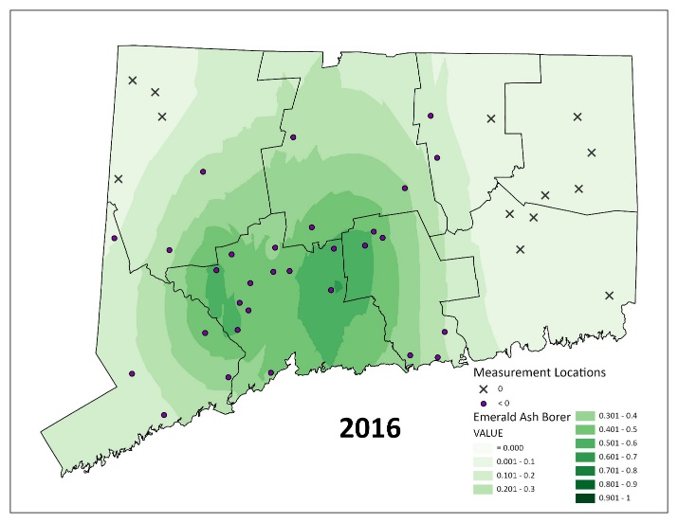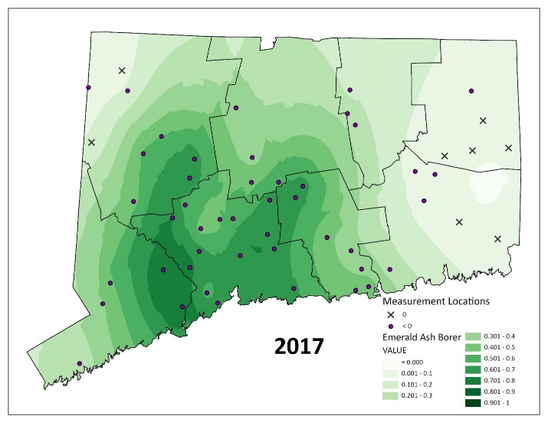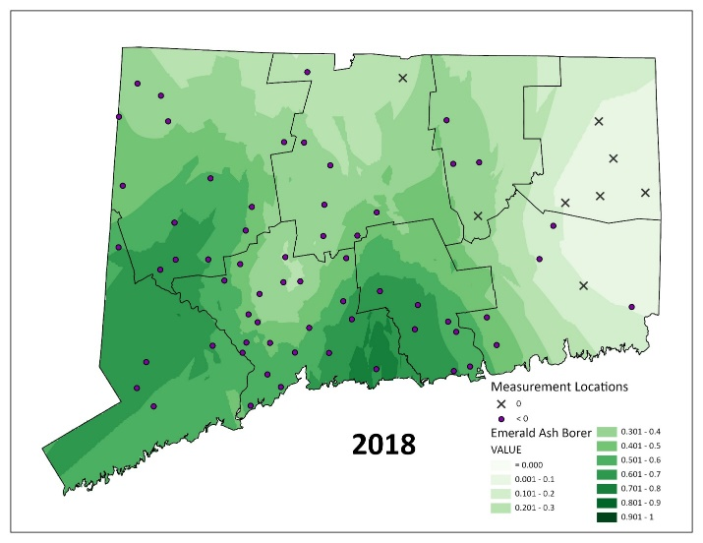

Supplemental Data Supplemental Data

Table 1. Statistics by year for Empirical Bayesian Kriging. Analysis was run in ArcPro (Esri 2022).

|  |  |  |  |  |  |  |  |  |  |  |
| --- | --- | --- | --- | --- | --- | --- | --- | --- | --- | --- |
|  | **Year** | | | | | | | | | |
|  | **2012** | **2013** | **2014** | **2015** | **2016** | **2017** | **2018** | **2019** | **2020** | **2021** |
| **Mean Error** | 0.003079 | 0.006615 | -0.00349 | 0.004463 | 0.014745 | 0.015735 | 0.008352 | -0.00018 | -0.00393 | -0.01598 |
| **Root-Mean-Square** | 0.025506 | 0.071365 | 0.120017 | 0.167545 | 0.219184 | 0.24788 | 0.275509 | 0.212609 | 0.25388 | 0.229482 |
| **Mean Standardized** | 0.11477 | 0.090324 | -0.02315 | 0.01353 | 0.049474 | 0.047991 | 0.023972 | 0.004329 | -0.01325 | -0.04676 |
| **Root-Mean-Square Standardized** | 0.980368 | 0.986514 | 0.897049 | 0.968091 | 0.963086 | 0.985122 | 0.999567 | 0.957663 | 0.999082 | 0.954591 |
| **Average Standard Error** | 0.026372 | 0.073224 | 0.149662 | 0.182537 | 0.23601 | 0.256197 | 0.273613 | 0.225082 | 0.252313 | 0.249121 |

Supplemental Data – Table 1. Logistic generalized linear mixed model for the proportion of EAB as a function of time. Z-scores and *p* values are specified for fixed effects, and log Likelihood and AIC are specified for random effects (in italics). The best random effects structure was selected based on (lowest) AIC. Significant terms are highlighted in bold.

|  |  |  |
| --- | --- | --- |
| **Term** | **Z value/*logLik*** | **p/*AIC*** |
| **Fixed Effects** |  |  |
| Time | 6.68 | **< 10-10** |
| Time2 | -6.31 | **< 10-9** |
| ***Random Effects*** |  |  |
| *(1 + Time + Time2 | Site)* | *-1121* | ***2261*** |
| *(1 + Time | Site)* | *-1443* | *2899* |
| *(Time | Site)* | *-1443* | *2899* |
| *(1 | Site)* | *-2083* | *4173* |

Figure 1. A map of emerald ash borer detection in the state of Connecticut by year and method. The presence of emerald ash borer in 3 of the 169 towns remains officially unconfirmed, but it is assumed.

5

0

5

1

0

M

i

l

e

s

1

:

7

5

0

0

0

0

2012

County Boundary

Town Boundary

2013

2014

2015

2016

1st Detection Method

wasp

trap

DEEP survey

visual

Year EAB detected

2017

2018

d

2019

2020

2021